**XGBoost Model: A Powerful Machine Learning Algorithm 🚀**

XGBoost (**eXtreme Gradient Boosting**) is one of the most powerful and efficient machine learning algorithms, especially for **structured/tabular data** like yours (call volume forecasting). It is widely used in data science competitions and real-world applications due to its **speed, accuracy, and ability to handle large datasets**.

XGBoost is based on **Gradient Boosting**, which builds multiple weak models (typically decision trees) in **sequence**, where each new tree corrects errors made by the previous trees.

🔹 **Step-by-Step Process:**

1️ **Initialize the model** → Start with an initial guess (e.g., the average call volume).  
2️ **Build decision trees** → Each tree improves the previous one by focusing on errors.  
3️ **Gradient Descent Optimization** → Adjusts predictions step by step.  
4️ **Final prediction** → Combines all trees' results into a strong prediction model.

**Q. Why Use XGBoost for Your Forecasting Model?**

✅ **Handles Large Datasets Efficiently**  
✅ **Prevents Overfitting** using built-in regularization  
✅ **Fast Training Time** due to parallel computation  
✅ **Automatically Handles Missing Values**  
✅ **Supports Feature Importance Analysis**

XGBoost (Extreme Gradient Boosting) is an advanced implementation of the gradient boosting algorithm. It is optimized for speed and performance by implementing key techniques such as regularization, parallel computation, and tree pruning.

**Mathematical Calculation Behind XGBoost**

XGBoost builds decision trees sequentially, improving each tree based on the errors of the previous trees. Here's the step-by-step breakdown of the calculation:

**1. Define the Objective Function**

XGBoost optimizes a loss function using gradient boosting. The loss function LLL measures the difference between actual and predicted values:

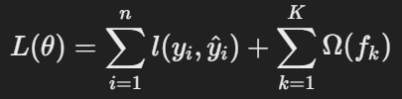

where:

* yi = actual value
* y^i​ = predicted value
* l(yi,y^i) = loss function (e.g., Mean Squared Error for regression)
* Ω(fk) = regularization term to control complexity
* K = total number of trees

For regression, a common loss function is Mean Squared Error (MSE):



**2. Gradient and Hessian Computation**

At each boosting step, we compute the first derivative (gradient gi​) and second derivative (Hessian hi​) of the loss function with respect to predictions:

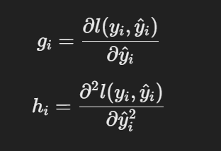

For MSE loss:

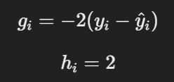

**3. Construct Decision Trees**

Each decision tree partitions data into leaf nodes based on feature values. XGBoost uses a **gain function** to determine the best split:

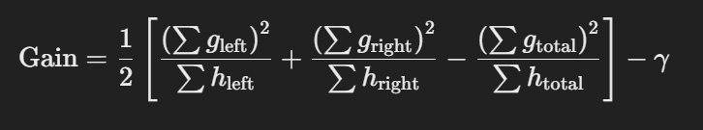

where:

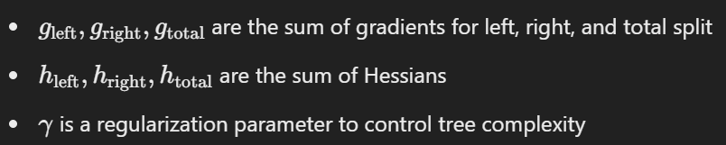A split occurs only if the gain exceeds a threshold.

**4. Update Leaf Weights**

For each leaf node, the optimal weight w* is computed as:

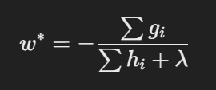

where:

* λ is a regularization parameter for leaf weights

**5. Add the New Tree to the Model**

The final prediction at step ‘t’ is updated as:

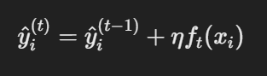

where:

* η is the learning rate (controls how much the new tree contributes)
* ft(xi) is the output of the new tree

This process repeats for multiple iterations until convergence.

**Optimization Techniques Used**

1. **Shrinkage (Learning Rate, η)** - Reduces overfitting by scaling new tree contributions.
2. **Column Subsampling** - Randomly selects features to reduce correlation and improve generalization.
3. **Tree Pruning** - Uses the parameter γ to remove splits that do not improve the objective function.
4. **Regularization (λ, α)** - Controls model complexity to prevent overfitting.